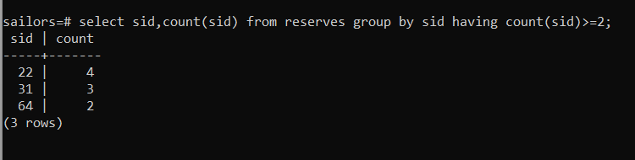

Select s.sid,count(r.bid) from sailors s , reserves r where s.sid=r.sid group by s.sid having count(r.bid)>=2



